Take a Trip to Lucknow
Pre-Visit Activity
Time Required: Mid-length Activity (30-40 minutes)

Activity Overview

While pretending to be a guest of Tom and Olive Plant, prepare a packing list for a stay at the Lucknow Estate, and follow up with either a thank you letter to your hosts or a diary entry about your trip.

Learning Targets

- I CAN use historic photographs to visualize what life was like in the 1920s.
- I CAN compare my experiences to those of people from the past.
- I CAN develop lists based on their observations and comparisons.
- I CAN summarize my imagined experiences by writing a diary entry or a thank you letter

Guiding Questions

- Based on the photographs, what was life like for people in the 1920s?
- Without modern technology, what activities would you do?
- How do the photographs compare to your life today?

Activity:

- Read the story of Tom and Olive Plant.

- Use the provided slide show to launch the lesson and introduce the activity.

- Have students CHOOSE to either write a thank you note to the Plants about their trip OR write a diary entry about their stay at Lucknow mansion. They may use the provided templates and/or sentence starters or free write.

Take a Trip to Lucknow
Thank You Letter

Activity:

Write a thank you note to Tom and Olive Plant about your trip to Lucknow. Make sure to tell them how the trip was and what activities you did while there. You can use the template below or write your own.

Optional Sentence Starters:

- Thank you so much for ______________________.
- My trip to Lucknow was_________________.
- While I was there I _____________________.
- I also________________________.
- I really enjoyed ____________________.

*make sure to end your letter with another Thank you!*

Dear __________________________________,

_______________________________________________

_______________________________________________

_______________________________________________

_______________________________________________

_______________________________________________

_______________________________________________

_______________________________________________

Sincerely,
_____________
Take a Trip to Lucknow
Thank You Letter

Activity:

Write a thank you note to Tom and Olive Plant about your trip to Lucknow. Make sure to tell them how the trip was and what activities you did while there. You can use the template below or write your own.

Finish the sentences below:

Dear Tom and Olive Plant,

Thank you so much for ____________________________

______________________________________________.

My trip to Lucknow was____________________________

______________________________________________.

While I was there I _______________________________

______________________________________________.

I also__________________________________________.

I really enjoyed _________________________________

______________________________________________.

Sincerely,
____________________

Take a Trip to Lucknow
Thank You Letter

Activity:

Write a thank you note to Tom and Olive Plant about your trip to Lucknow. Make sure to tell them how the trip was and what activities you did while there. You can use the template below or write your own.

Circle the icon that best finishes your sentences:

Dear Tom and Olive Plant,

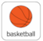

for having me at Lucknow. My

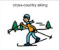
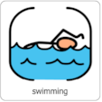

favorite thing to do was . . I also

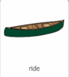
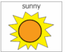
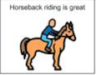

enjoyed . The weather was

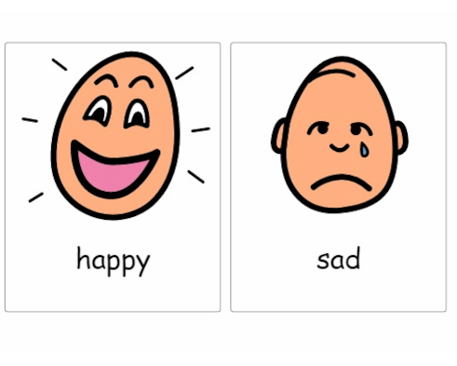
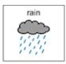

. The trip made me .

Sincerely,
__________________
Take a Trip to Lucknow
Diary Entry

Activity:

Write a diary entry about your trip to Lucknow. Include details about what you did while you were there such as activities you did, what the weather was like, etc. You can use the templates provided or free write.

Optional Sentence Starters: (don’t forget to include the date!)

- I just got back from a trip to ________________.
- While I was there I_____________________.
- I also_______________________.
- The weather was __________________.
- I really enjoyed_____________________.

____________________
(month, day, year)
Dear Diary,

_______________________________________________

_______________________________________________

_______________________________________________

_______________________________________________

_______________________________________________

_______________________________________________

_______________________________________________

Till tomorrow,
________________
Take a Trip to Lucknow
Diary Entry

Activity:

Write a diary entry about your trip to Lucknow. Include details about what you did while you were there such as activities you did, what the weather was like, etc. You can use the templates provided or free write.

Finish the sentences below: (don’t forget to include the date!)

______________________
(month, day, year)

Dear Diary,

I just got back from a trip to _________________. While I

was there I _____________________________________

______________________________________________.

The weather was_________________________________.

I really enjoyed__________________________________

______________________________________________.

Till Tomorrow,

___________________

Take a Trip to Lucknow
Diary Entry

Activity:

Write a diary entry about your trip to Lucknow. Include details about what you did while you were there such as activities you did, what the weather was like, etc. You can use the templates provided or free write.

Circle the icon that best finishes your sentences:

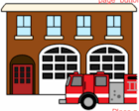
Dear Diary,
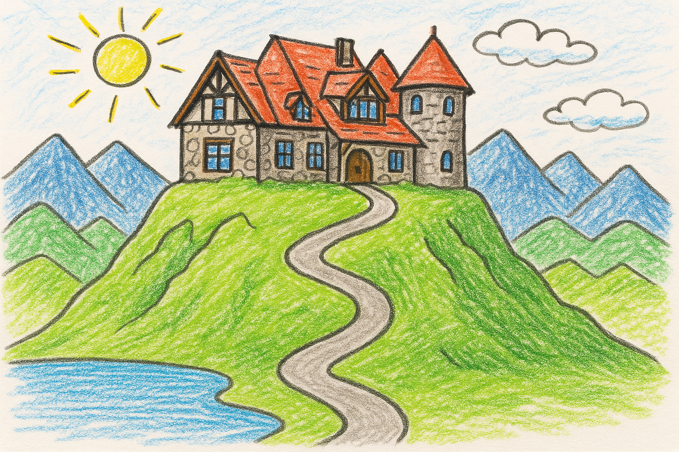
I just got back from a trip to . While I

was there I went . I also enjoyed

. The weather was .

The trip made me feel .

Till tomorrow,

____________________

Take a Trip to Lucknow
Packing List

Activity:

Based on what you know about the weather in New England and the activities you might be doing, create a packing list for your trip to the Lucknow Mansion. Use the template provided below or free write if you would like.

Packing List:
Possible items
- Bathing suit for swimming
- Winter coat for skiing
- Hat for sun or cold

_______________________________________________

For my trip to Lucknow I will bring…

- ______________________

- ______________________

- ______________________

- ______________________

- ______________________

- ______________________

- ______________________

- ______________________

- ______________________

- ______________________

Take a Trip to Lucknow
Packing List

Activity:

Based on what you know about the weather in New England and the activities you might be doing, create a packing list for your trip to the Lucknow Mansion. Use the template provided below or free write if you would like.

Circle which item you would like to bring:
